Case Study 9.2: Dangers in co-managing a technically failed FCL . V 1.0
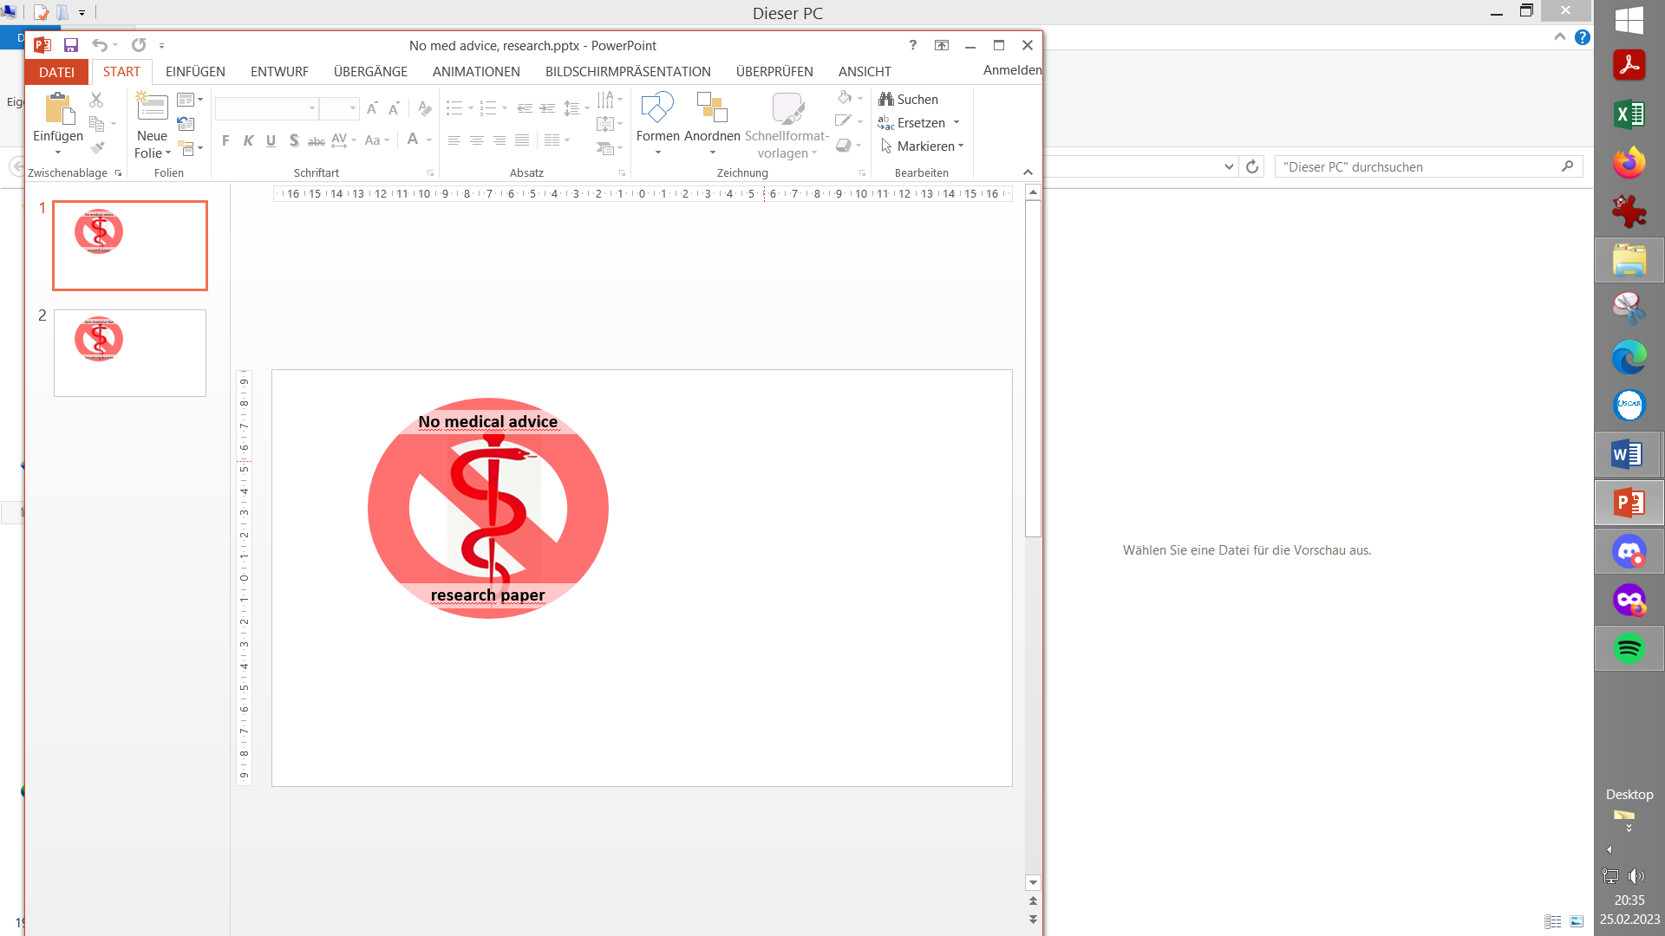

This case is about interventions after detecting a technically failed loop

METHOD

FCL (no carb inputs, no user boli) with dev variant of AAPS 3.3.a w/autoISF 3.1:
Lyumjev 100 (DIA 8.5 h) in Combo pump w/ 10mm Teflon cannula (0-48h)
2 x G6 overlapping (see case study 1.5; sensors used ~ d2 – d14; xDrip, no smoothing in AAPS)
TDD ~ 40 U; profile basal ~ 14 U (0.41…0.75 U/h); profile_ISF 36…44 mg/dl/U; iobTH% = 0.6 @ iobMAX 10 U
Key settings*) for entire meal spectrum (~ 20 … 90 g carb per meal):
SMB size limited at ~ 3.5 U (=2.9 x 120 minutes basal)
autoISFmax = 2.9; SMB delivery ratio = 0.75 fixed
bgAccel_ISF_weight = 0.22; break_weight 0.12; lower_ISF-range_weight 0.7; higher_ISF-range_weight 0.1; pp_ISF_weight = 0.03; dura_ISF_weight 0.7
Activity modifies sensitivity w scale factors 1.2 (at activity) and 0.3 (at in-activity)
*) Caution: Do not copy settings from others, not even for starting your tuning. Why, see FCL e-book section 4.1.

MANUAL CORRECTIONS MADE AFTER A TECHNICAL FAILURE

After a nice Christmas period (see Case Study 4.3), apparently a phase with increased negligence set in, resulting in noticeably worsened loop performance despite “easier” meals.

Lost insulin delivery (un-plugged cannula)
The following is an example how losing cannula or pod connection during sleep will make for a bad next days, starting with very high values, followed likely by a roller-coaster.
In the specific example, the loss of connection was even self-induced: I got a low alarm at 02:30 am (when sleeping). So I took 2 glucose tablets (4 g total). Now, at a hypo, and even more so if one happens in the middle of the night without you seeing it coming, you are not the clearest thinker.
What I had thought about was, that my FCL tends to “fight” bg rises, and chances could be high that 1-2 hours later another hypo develops. So, I just unplugged the cannula, meaning to put it back on 20 minutes later, when the glucose had “jumped in”. – Of course, I fell back asleep, the bg kept ever climbing, up to about 240 mg/dl, and iob was solidly negative 8 am when I got up:
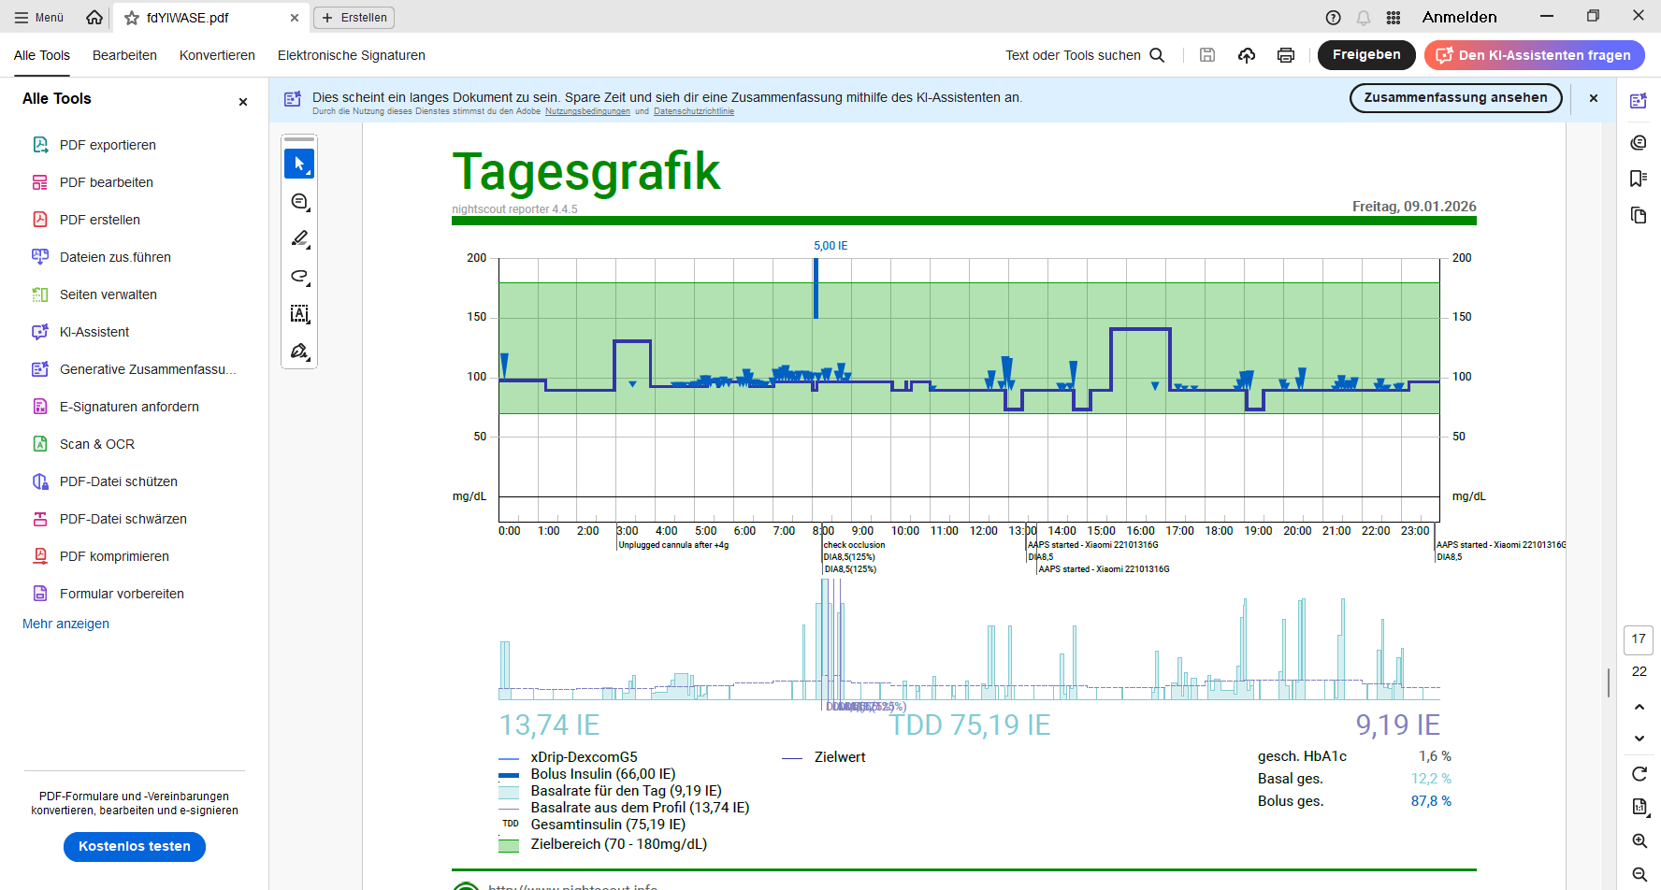
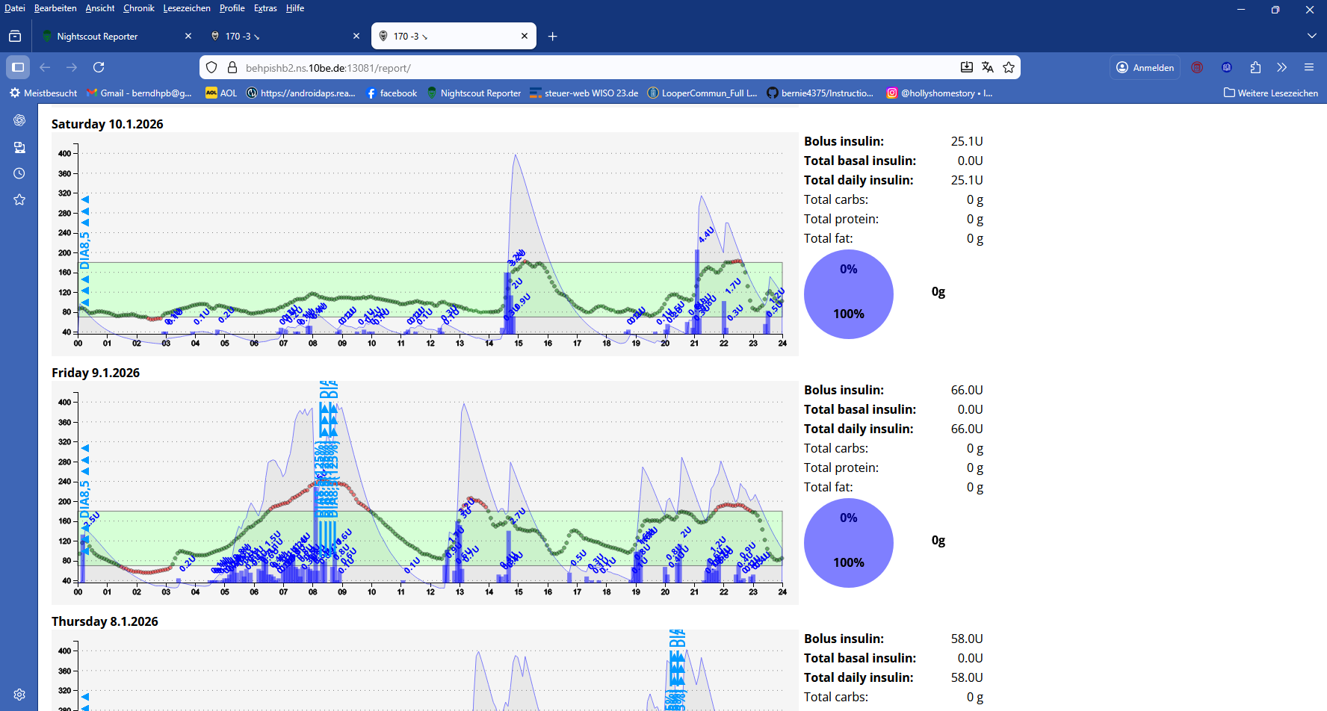

Frustrated about the – since hours – high and climbing bg, I felt I should give a substantial bolus. I recorded 5 U given with pen, and that worked well.
Actually, I set the pen to give 6 U because I always have the feeling that it does not deliver what I set it to. (For my next prescription, I use the “Junior” version of Lyumjev pens, which allow delivery by the half unit, and thus give a better precision and “feeling” that actually desired amounts go in).

Loop lost with dying phone battery charge, followed by manual over-correction
Just two days later I had the next severe incidence with a mismanaged – and, again, very trivial - technical failure: This time, my phone charge just had gotten to zero. And this happened after dinner, without me noticing, for nearly two hours (~ 19:00 – 20:30 h). As it takes a couple of minutes until the phone charged up sufficiently for a re-start, plus up to 5 minutes for the next-arriving bg value, update of the pump etc, I elected to give a quick shot with the pen while the system sorts itself:
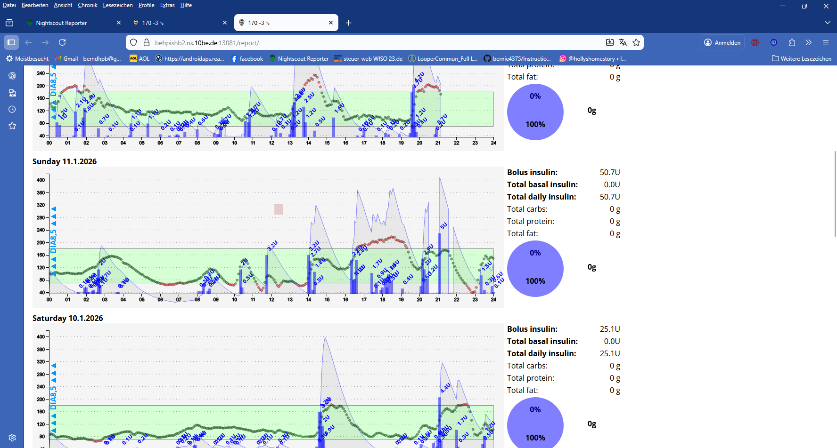
IE stands for U

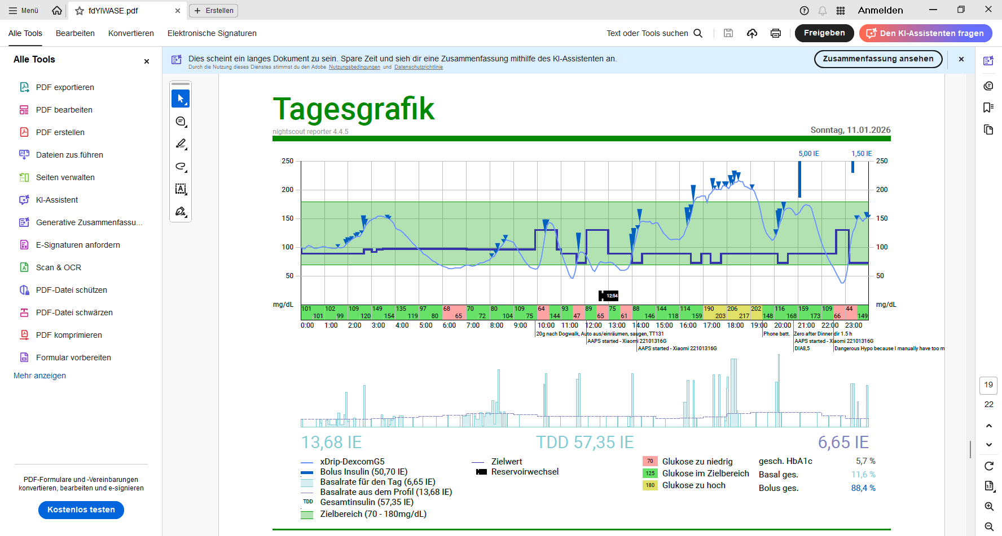
Note that it was highly time-critical to enter these 5 U into AAPS *) as insulin given by pen, after the phone has powered up, but before the loop determined missing iob and starts giving SMBs. (That would have aggravated the problem, likely requiring emergency medical intervention with glucagon!)
*) to do this, I had to first re-install my insulin button via Preferences/Overview/Buttons. Then, from the AAPS home screen, bottom button “Insulin”, to click “Do not bolus, record only” and type in the units / OK.
Tipp: If your pump system allows that, unplug the cannula until you sure have this data entry made, and the loop factors it in (may require to wait for one more 5 minute CGM segment; but, no rush to plug cannula back, as a big manual bolus was just given).

Correcting low bg with glucose tablets can lead to another hypo if FCL acts too aggressively against the intended temp. bg rise


In the Sunday 11 Jan. chart we see yet another severe hypo problem;
A 10:00 am light hypo had resulted after a dogwalk.
The snack led to a 2 U plus a 0,5 U SMB around 10:30 am, an led to a (worse) hypo at 11:30 am. H
This was again relating to an over-reaction of my FCL to an intended small rise of bg.

DISCUSSION
In the reported days I struggled with a roller-coaster pattern that developed when poorly managing three inter-linked problems:
- Loss of technical functions leading to extreme values (usually high)
(Could also result in a low when hitting in a phase when the FCL counter-regulates by zero-temping. Some pre-cautions exist in AAPS, which continues zero-temping for a while in some instances of losing BT connection)
- Manual bolussing for rapid correction of highs can lead to severe hypos
- Correction of low bg with carbs can make FCL act too aggressive => the roller-coaster continues.

Avoiding (late detection of) technical failure
The best way to stay out of trouble is of course to avoid technical failures.
See below under KEY LEARNING POINTS

Watch(ing your FCL) ?
In his 3+ years of FCL, the author consciously never used a wristwatch. It seems to defeat the purpose of a FCL to frequently monitor what is going on.
Also, looking at the data all the time could make you lean towards immediate interferences into your FCL, or constant tinkering with settings. (Refer to Case Study 8.2 about dangers when tinkering!).
During tuning, I needed more info than a watch-face could display.
And later, FCL is supposed to run hands-off.
I am still not ready to switch position on that.
However, using a watch can give you an extra degree of “situational” freedom.
For instance, if you might run into a problem, you can ask yourself whether you “can afford” the care-free route = eventually to run into an alarm, and manage it.
Or whether you rather monitor the development closer, for an earlier intervention (without having to “play with your phone constantly” to avoid alarms).

Alarms for early detection of technical failures
Clearly, AAPS (and also xDrip) allow to set up sophisticated alarms that everyone can, over time, tailor to their exact needs.
- AAPS offers alarms alerting to the technical problem itself, like “no BT connection since “, or “missing bg values since..”. Make use of those!
- Alarms also can pick up patterns of bg delta, of present iob etc. and allow temp. shut off SMBs, setting different % temp. profile etc. All this can easy be differentiated also by time-of-day, or even by geo-location to – fully automated –get just the alarms that you want to hear.
The importance of this is often under-estimated.
  - AAPS users often lean towards switching off alarms (thinking about their partners, families, work colleagues). A frequent situation is the counter-regulated correction of a high bg which – depending on your set glucose target - might swing through your low-bg alarm zone, but automatically self-corrects. Clearly, such alarms would only be annoying, and without real significance. However, this case study suggests more effort should go into your personally tailored “custom design” set of alarms - that rarely would come on, but then really deserve to be heard.
  - By contrast, commercial systems allow very little flexibility re. alarms (for liability reasons). They are notorious for leading to “alarm fatique”.

What would be a safe way to prevent too much insulin given by the FCL when a small correction with glucose tablets drives bg back up?
Note: When using SMBs, you have a similar problem in Hybrid Closed Looping, so this paper applies largely to FCL and to HCL.

Hypo TT
Pressing the TT button (AAPS home screen, top right) and selecting HypoTT sets a TT of 131 mg/dl and shuts any SMBs off for 55 minutes. That is usually sufficient safe-guarding agains the FCL giving too much insulin when seeing the rise from the hypos snack, which by definition is a small but fast (short in duration) carb-related rise.
All my Automations that could deliver more insulin at a bg rise have “no TT set” among the pre-conditions.

Nightime SMB off / temp on
Potential problems with my nighttime Automations were recently discussed in the extended Case Study 4.3 (Christmas).
What hurt me on Friday 02:30 am is that my odd-numbered profile target for nightly SMBs-off starts at 03:00 am, so only from then on is my well-thought-out night routine valid.
At 02:30 am, I was running on an even profile target. Instead of un-plugging my cannula for half an hour, I could have set an odd TT – but just up to 03:00 am, because then I need my odd profile target as a basis for my Automations (remember: they get blocked by any other Automation with a TT running!).
The best solution for me seems to be to define an earlier starting point for my nighttime odd profile target.
Then I could - without later hypo risk from a FCL over-reaction - just take one or more glucose tablets when the low alarm sounds.
Better yet, I should make it a habit at around bedtime to look at the predicted insulin activity curve, think about whether most carbs and FPUs are digested, and whether recent exercise calls for less insulin. A combination of reduced %profile and set elevated odd TT should prevent the bg from going low at night. A little bedtime snack may be useful, too, but only if you figured out how to keep your loop response “tame”.
The earlier start of an odd profile TT at night can have a disadvantage in (for me, rare) instances with very late fatty dinners (which may need a duraISF driven SMB after 02:00 am). For such nights, I could run an even target longer, just by setting it manually before going to bed, or by defining a “party night” profile (that could cover additional tweaks).

KEY LEARNING POINTS (see also similar case study 1.6)

Key is to get into a habit that would secure 24/7 technical function:
- clothing that makes it easy to keep the phone constantly on you (jacket, or belt pouch)
- phone re-charging during the day (even if most days it would work without re-charge)
- new pump battery earlier than would still work on most days
- regular, rather early, cannula or pod changes
- 2 overlapping G6 (see case study 1.5)
That will keep instances with problems very low.
- Alarms should – over time – be tailored to YOUR remaining occasional/possible problems, and they would happen very infrequently.
- Decide for yourself, how often you like to check on your FCL, and whether a wristwatch display of some key data would be of help.

You set up your FCL to do (nearly) everything fully automatically. So manual interventions - after you resolved a technical problem - can be problematic.
- Of course, taking fast carbs remains essential in a hypoglycemia. However, resist the sweet temptation to over-do it with too many g of carbs.
- Refer to the DISCUSSION section above for how to prevent your FCL acting too harsh on bg rises that are just meant to bring you out of the hypo zone.
Also, check whether all your Automations work as intended. Your active Automations are checked, at all AAPS dosing decision points, in the listed sequence, and one kicking in will usually exclude any others, the entire time while it is active. (This is a reason for defining a) not too many Automations and b) a short duration for each of them).
- Regarding correcting high bg, it might just be best to give it the extra minutes to let your FCL take care of it. Too often you will, out of frustration, act too aggressively. The desire to “save” a few %TIR above range for the respective day, too often will induce a roller-coaster, and end up even worse.
- Warning: Overdosing very rapid insulins (especially Lyumjev) can be really dangerous because bg sinks rapidly, with a very narrow time window for rapid carbs (orange juice, glucose tablets …) to rescue you. Be aware that you will not be the usual clear thinker when in a hypo. Have a strategy when/how glucagon and emergency medical support can be available to you within minutes, if required.

I like to summarize that none of the problems discussed in this paper were really due to the FCL algo or my settings. Rather, they all related to technical failures of single system components, and to ill conceived interventions.
Besides securing a technically smoothly running loop, my advice is to periodically review your data with your doctor, and staying away from over-ambitious goals about your desired bg target and range. (It comes with exponential extra effort, and too often back-fires, too).

